Can you label your room in Spanish? You might use your wordbanks.
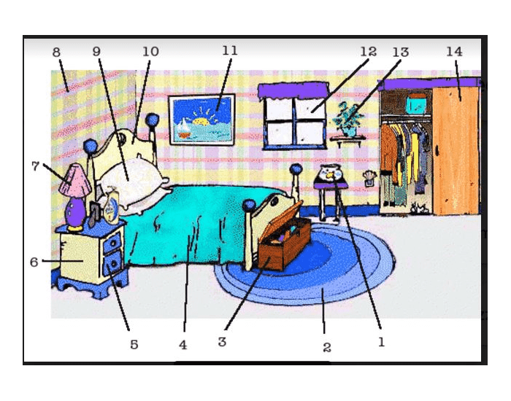
Almohada cuadro cama lampara mesita edredon baul pecera ventana pared maceta armario alfombra cajon

