Do you know Spain?
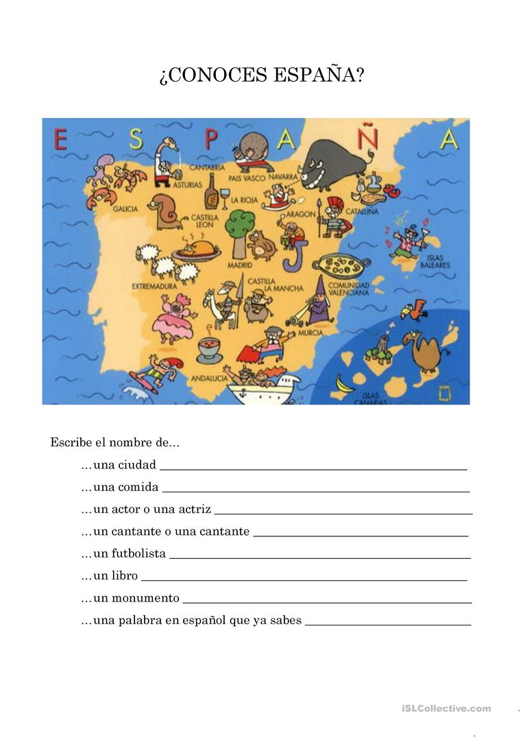
Write the name of : a town, a meal, an actor/actress/a footballer/a monument/a Spanish word that you already know.

