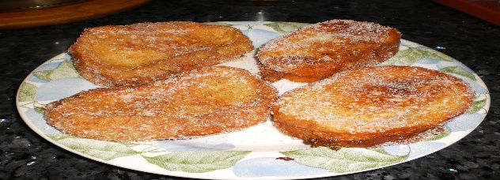
How to make Torrijas – Cinnamon toast

Lo que necesitas- What you need (label in Spanish the following ingredients)
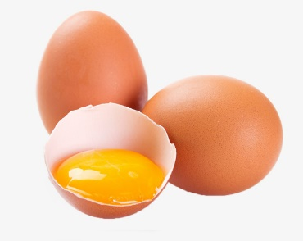
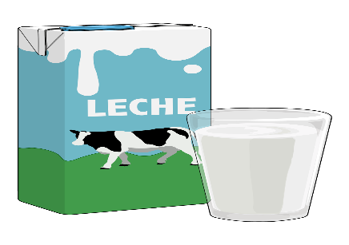
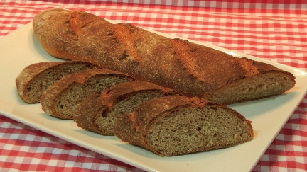

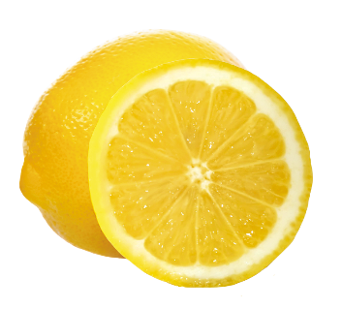
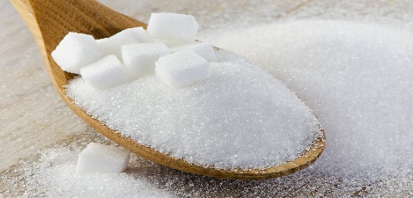
_________________ __________________ ___________________
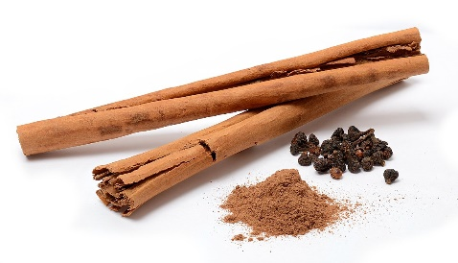

____________________ _____________________ ______________________
Huevos azúcar canela leche limón Pan

Qué hacer- What to do.
Step 1- Paso 1 - Cortar el pan duro en rebanadas gruesas y diagonales .
Step 2- Paso 2- Poner leche a hervir con canela y la oiel de un limón
Step 3- Paso 3- Mojar las rebanadas de pan duro en la leche templada.
Step 4- Paso 4 -Pasar las rebanadas por huevo batido.
Step 5- Paso 5- Freir en una sartén con abundante aceite hasta que estén doradas por ambos lados .
Step 6- Paso 6- Poner en un plato y espolvorear con azúcar y miel.
Step 7- Paso 7 Servir y disfrutar.


Cut and place the English sentence next to each Spanish step.
---------------------------------------------------------------------------------
Soak the slices of bread in the cooled down milk mixture.
--------------------------------------------------------------------------------
Put them in a plate and sprinkle the sugar and honey over.
-------------------------------------------------------------------------------
Bring the milk with the cinnamon and the peel of a lemon to the boil.
-------------------------------------------------------------------------------
Serve and enjoy.
-------------------------------------------------------------------------------
Cut the hard bread into thick and diagonal slices.
------------------------------------------------------------------------------
Fry the slices in a pan with lot of oil until golden on both sides.
-------------------------------------------------------------------------------
Dip the slices in the egg mixture.
--------------------------------------------------------------------------------

