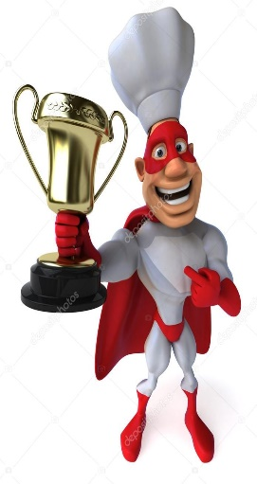
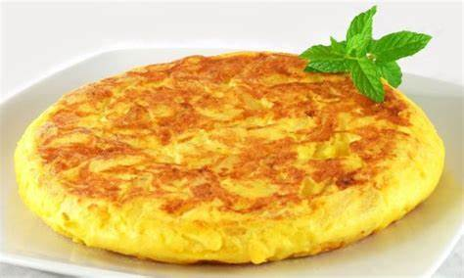
- Watch this video and do not write anything yet.
https://www.youtube.com/watch?v=FAHnZ3VtGBg
Circle the ingredients mentioned in the video.

- Write the correct letter into the correct circle of every picture.
- Listen to the cook and complete the sentences.
La cebolla Pela el huevo el aceite
estén blandas sartén las patatas sal la cebolla
el huevo sartén lavar lento después
