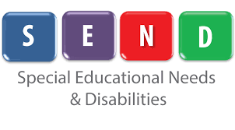
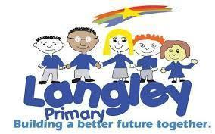
INTENT IMPLEMENTATION AND IMPACT - LANGLEY PRIMARY SCHOOL
SEND provision

INTENT | IMPLEMENTATION | IMPACT
At Langley Primary School, we believe that all children are entitled to receive a high-quality education regardless of their needs or disabilities. We believe that it is vital that our children are equipped with the tools needed to become independent learners, both inside and outside of the classroom. All children and young people should expect to receive an education that enables them to achieve the best possible outcomes, and become confident, able to communicate their own views and ready to make a successful transition into secondary school and then adulthood.  Through our first-quality teaching, planning and provision we: -  - Ensure that needs are identified as early as possible and support is put into place.  - Ensure that children have access to a broad and balanced curriculum which is appropriately differentiated to enable children to succeed.  - Provide an accessible learning environment which is tailored to the needs of all pupils.  - Develop children’s independence.  - Regularly monitor the progress of children with SEND.  - Work closely with parents and carers.  - Work closely with external agencies and other professionals to ensure that there is a collaborative approach to support children with SEND. | At Langley Primary School, every teacher is a teacher of SEND. Our provision is enhanced by the collaboration of teachers, senior leaders, the SENDCo, support staff, external agencies, parents and most importantly the child.  Pupils with SEND will:  - Be included in all aspects of the school day  - Be provided with first quality teaching, adapted to meet their needs  - Be respected and acknowledged  Pupils with SEND may:  - Have specific 1:1 or group support to support them accessing different areas of the curriculum.  - Have interventions outside of the classroom.  - Take part in social, emotional and mental health interventions such as emotion coaching.  - Receive additional support from a Speech and Language Therapist.  - Work alongside outside agencies such as the Educational Psychologist, Occupational Therapist, Social, Emotional and Mental Health team, Communication and Interaction team and the Specific Literacy Difficulty team. | As a result of the provision above, children at Langley Primary School will:  - Feel safe, secure and cared for.  - Show confidence and resilience in the classroom.  - Demonstrate high levels of engagement in activities.  - Make progress from their starting points.  - Develop independence and skills to support them throughout life.  - Work collaboratively with their peers on a shared task.

