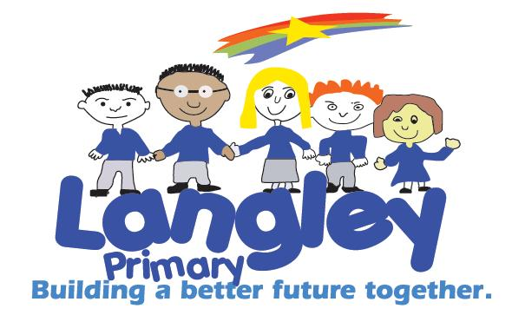
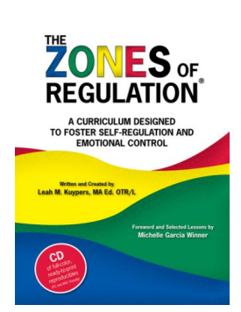

A Parent’s Guide to the Zones of Regulation

The Zones of Regulation is an internationally renowned intervention that helps children manage difficult emotions, known as self-regulation.
Self-regulation can go by many names such as ‘self-control’, impulse management and self-management. Self-regulation is best described as the best state of alertness for a situation. For example, when your child takes part in a sports game, they would need to have a higher state of alertness than when, for example, they were working in a library.
From time to time, all of us (including adults) find it hard to manage strong feelings such as worry, anger, restlessness, fear or tiredness, and this stops us from getting on with our day effectively. Children who feel these emotions often find it hard to learn and concentrate in school. The Zones of Regulation aims to teach children strategies to help them cope with these feelings so that they can return to feeling calm and ready to learn. These coping strategies are called ‘Self- regulation’
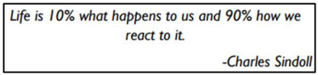
At Langley Primary School, we have launched the Zones of Regulation throughout the whole school. We want to teach all of our children good coping and regulation strategies so that they can help themselves when they experience anxiety and stress. In the classroom, sometimes children panic when faced with a tricky learning problem or challenge. By teaching them how to cope with these feelings might make them better at tackling learning challenges and build better resilience so they don’t give up so easily when faced with difficulty.
We want children at Langley to grow into successful teenagers and adults. Teaching children at a young age about managing their feelings will support them in later life so that they don’t turn to negative coping strategies which affect their mental and physical well-being.

We aim to help children to:
- Recognise when they are in difficult zones and learn how to change or stay in the zone that they are in.
- Increase their emotional vocabulary so they can explain how they are feeling.
- Recognise when others are in different zones, thus developing better empathy.
- Develop an insight into what might make them move into different zones.
- Understand that emotions, sensory experiences such as lack of sleep or hunger and their environment might influence which zone they are in.
- Develop problem-solving skills and resilience.
- Identify a range of calming and alerting strategies that support them (known as their personal ‘toolkit’)

What are the different zones?
Blue zone – Low level of excitement; not ready to learn; feels sad, sick, tired, bored, moving slowly.
Green zone – Calm state of alertness; optimal level to learn; feels happy, calm, feeling okay and focussed.
Yellow zone – Heightened state of alertness; elevated emotions; has some control; feels frustrated, worried, silly, wiggly, excited and loss of some control.
Red zone – Heightened state of alertness and intense emotions; not an optimal level for learning; out of control; feels mad, angry, terrified, yelling, hitting, elated and out of control.

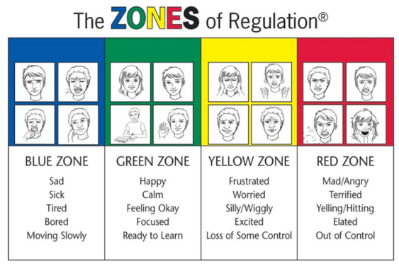
We teach the children that everyone experiences all of the zones. The red and the yellow zones are not ‘bad’ or ‘naughty’ zones. All of the zones are expected at one time or another. We show them that the blue zone, for example, is helpful when you are trying to fall asleep.
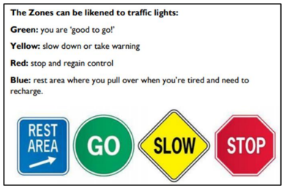

How will my child learn about the Zones of Regulation?
We introduced the zones through discrete teaching lessons and through our PSHE curriculum. We have also been using the zone language as part of daily school life so all staff refer to them, not just their class teacher.
Some children might prefer not to use ‘zones language’ but label their emotions directly – This is fine and encouraged!
How can you help your child use The Zones of Regulation at home?
- Identify your own feelings using Zones language in front of your child (e.g.: I’m frustrated. I think I am in the Yellow Zone.”)
- Talk about what tool you will use to be in the appropriate Zone (e.g.: “I need to take four deep breaths to help get me back to the Green Zone.”)
- At times, wonder which Zone your child is in. Or, discuss which Zone a character in a film/book might be in. (e.g.: “You look sleepy. Are you in the Blue Zone?”)
- Engage your child in discussion around Zones when they are in the Red Zone is unlikely to be effective. You need to be discussing the different Zones and tools they can use when they are more regulated/calm.
- Teach your child which tools they can use. (eg: “It’s time for bed. Let’s read a book together in the comfy chair to get you in the Blue Zone.”)
- Regular Check-ins. “How are you feeling now?” and “How can you get back to Green?”
- Modelling It is important to remember to show the children how you use tools to get back to the green zones. You might say “I am going to make myself a cup of tea and do some breathing exercises because I am in the blue zone” and afterwards tell your child how using those tools helped you get back to the green zone.
- Share how their behaviour is affecting your Zone. For example, if they are in the Green Zone, you could comment that their behaviour is also helping you feel happy / go into the Green Zone.
- Put up and reference the Zones visuals and tools in your home.
- Praise and encourage your child when they share which Zone they are in.
Tips for practising the Zones of Regulation
- Know yourself and how you react in difficult situations before dealing with your child’s behaviours.
- Know your child’s sensory threshold. We all process sensory information differently and it impacts our reactivity to situations.
- Know your child’s triggers.
- Be consistent in managing your child’s behaviour and use the same language you use at home.
- Empathise with your child and validate what they are feeling.
- Have clear boundaries/routines and always follow through.
- Do not deal with an angry, upset child when you are not yet calm yourself.
- Discuss strategies for the next time when you are in a similar situation.
- Remember to ask your child how their choices made you feel (empathy).
- Praise your child for using strategies. Encourage your child to take a sensory break to help regulate their bodies.
- Create a ‘calm’ box full of things which help to keep your child calm and alert.

Common Questions on the Zones of Regulation
Can my child be in more than one zone at the same time?
Yes. Your child may feel tired (blue zone) because they did not get enough sleep, and anxious (yellow zone) because they are worried about an activity at school. Listing more than one Zone reflects a good sense of personal feelings and alertness levels.

Should children be punished for being in the RED Zone?
It’s best for children to experience the natural consequences of being in the RED zone. If a child’s actions/choices hurt someone or destroy property, they need to repair the relationship and take responsibility for the mess they create. Once the child has calmed down, use the experience as a learning opportunity to process what the child would do differently next time.

Can you look like one Zone on the outside and feel like you are in another Zone on the inside?
Yes. Many of us “disguise” our Zone to match social expectations. We use the expression “put on a happy face” or mask the emotion so other people will have good thoughts about us. Parents often say that their children “lose it” and goes into the Red Zone as soon as they get home. This is because children are increasing their awareness of their peers and expectations when in the classroom. They make every effort to keep it together at school to stay in the Green Zone. Home is when they feel safe to let it all out.

Where can I find out more about the Zones of Regulation?
www.zonesofregulation.com
www.weareteachers.com/zones-of-regulation-activities
https://www.theottoolbox.com/?s=zones+of+regulation
The Zones of Regulation - An Overview of The Zones for Parents https://hes-extraordinary.com/the-zones-of-regulation

