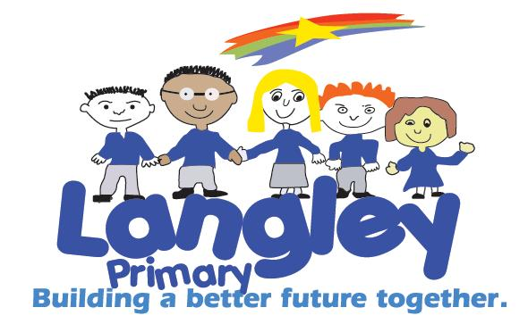

Langley Primary School Uniform

Boys
- Grey trousers
- White polo shirt or white shirt
- Royal Blue Sweatshirt
- Black Shoes
- Suitable outside coat with hood

Girls

- Grey Skirt or Pinafore Dress
- White Polo Shirt or white blouse
- Royal Blue Sweatshirt
- Black shoes (no heals)
- Grey tights or white socks
- Suitable outside coat with hood

PE Kit

- White t-shirt
- Black shorts
- Trainer or black pumps
- PE Bag
Uniform featuring our school logo, it is available to purchase from:



CC Uniforms Ltd, 82 Kings Square, West Bromwich, B70 7NW
or order online at www.ccuniforms.co.uk

Plain uniform with no logo can be purchased from many local supermarkets and high street clothing stores.

Book bags and water bottles are available to purchase from the school office.

Please remember to label all your child’s belongings including shoes with their first and last name – specialist name tags can be purchased online (many are iron-on) or names can be added to clothing labels with a biro or laundry marker. Remember there is less chance your child’s uniform ends up in lost property if it is clearly labelled – thank you.



