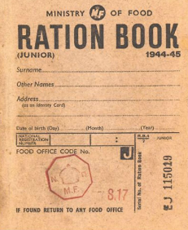
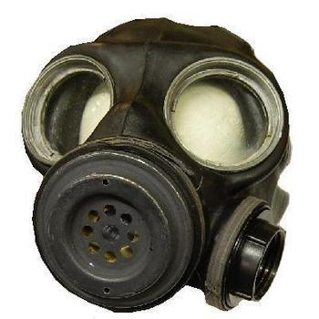
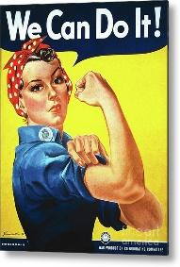
KEY INFORMATION
What was the Blitz?
The heavy and frequent bombing attacks on London and other cities was known as the 'Blitz'. Night after night, from September 1940 until May 1941, German bombers attacked British cities, ports and industrial areas. London was bombed every day and night for 11 weeks. One third of London was destroyed.
How did people protect themselves from the bombs during an air raid?
Air Raid Shelters were built to help prevent the Germans from seeing where the towns were, a blackout was rigorously enforced after darkness. All sources of light had to be blacked out.
What is evacuation?
During the Second World War, many children living in big cities and towns were moved temporarily from their homes to places considered safer, usually out in the countryside.
When did evacuations take place in Britain?
The British evacuation began on Friday 1 September 1939. It was called 'Operation Pied Piper'. World War Two ended in September 1945, however evacuation did not officially end until March 1946 when it was felt that Britain was no longer under threat from invasion. Surprisingly, even 6 months after the war had ended, there were still 5,200 evacuees living in rural areas with their host families.
What were ration books?
They were books which contained coupons that shopkeepers cut out or signed when people bought food and other items. (People still paid for the goods with money.) 'The colour of your ration book was very important as it made sure you got the right amount and types of food needed for your health. Buff-coloured ration books - Most adults had this colour Green ration books - Pregnant women, nursing mothers and children under 5. They had first choice of fruit, a daily pint of milk and a double supply of eggs. Blue ration books - Children between 5 and 16 years of age. It was felt important that children had fruit, the full meat ration and half a pint of milk a day.
Why did the government issue ration books?
To make sure that everybody got a fair share of the food available. The government was worried that as food and other items became scarcer, prices would rise and poorer people might not be able to afford things. There was also a danger that some people might hoard items, leaving none for others.
Why were there campaigns during the war?
Posters were created stressing the need to stop waste and unnecessary consumption, for the recycling of scarce material and for boosting food production from gardens and allotments.

LINKS TO USEFUL WEBSITES
https://www.youtube.com/watch?v=HFBlvWkNEKU – a video about a day in the life of an evacuee
https://www.dkfindout.com/uk/history/world-war-ii/ - an interactive site about all aspects of World War 2 – includes a quiz
https://www.iwm.org.uk/history/growing-up-in-the-second-world-war - information about what it was like to grow up in the Second World War

Knowledge Organiser
Everyone was issued with these ration books which contained coupons for food which was hard to get such as meat, cheese and butter

A protective mask used to cover a person's face as a defence against poison gas.

A poster with a slogan persuading parents to leave their children who had been evacuated to the country where they are.
KEY VOCABULARY
Anderson shelter | A small shelter made from corrugated steel to protect people from bombs. Usually found in the garden
Blackout | Wartime ban on street lights and other lights at night.
Blitz | German air raids on Britain from a German word ‘ blitzkrieg ‘ which means ‘ lightning war ‘
Axis | Countries which fought on the German side (including: Italy, Germany, Japan, Russia (1939-1941))
Allies | Countries which fought on the British side (including: USA, Great Britain, France, Russia (1941-1945))
Evacuee | Someone who was moved from a danger area to a safer place
Gas mask | Face mask to protect people against poison gas.
Home front | This was the name given for Britain during the war. It showed that everyone was involved in the war not just the soldiers.
Home guard | Men who were too old or unable to fight who trained as soldiers to defend Britain from invasion
Propaganda | Controlling news media ( such as radio and newspapers ) to show your side in the best way and to spread untruths about others.
Rationing | Controlling the supply of food, clothes and petrol.
Slogan | A catchy phrase or saying often on a poster
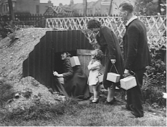
Key Leaders
Adolf Hitler - Leader of the Nazi Party and Chancellor of Germany, 1933 - 1945 (also referred to as the Führer meaning leader)
Winston Churchill - UK Prime Minister, 1940 - 1945 (and again from 1951 - 1955)
Neville Chamberlain - UK Prime Minister, 1937 - 1940 (infamous for failed attempts to satisfy Hitler’s demands prior to the war)
a small prefabricated air-raid shelter of a type built in the UK during the Second World War.

