What to Bring? Kit List - 2 Night Stay Why not pack together?

Please pack a backpack with these things that children will need every day outside.
- Wellies for wearing outside (bring in a plastic bag)
- Coat or / and Waterproof Jacket / Waterproof Trousers
- Thick socks
- Hat, Scarf, and Gloves; or Sunhat and Sun Cream
- Water Bottle
- Torch (not in summer term)
Please pack all other items in a small suitcase or bag. Children need to be able to carry this bag upstairs.
- Towel
- Wash kit (shower gel, toothpaste and toothbrush) ✓ Sleepwear
- Underwear and socks
- Slippers for the bedroom if you want
- 3 x t-shirts / long sleeved t-shirts
- 2 x jumpers / fleece or warm long sleeved tops
- 2 x long trousers
- 1 x old trainers, arrive wearing these
- Plastic bag for dirty clothing
Please name all the things children bring. Just bring old clothes as children will be outdoors having fun and getting muddy!
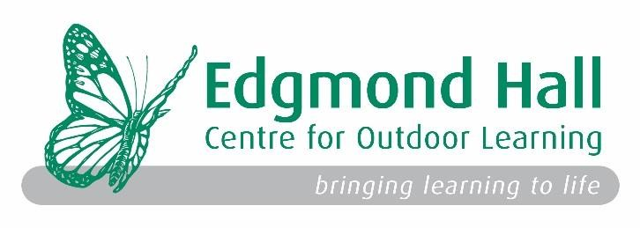
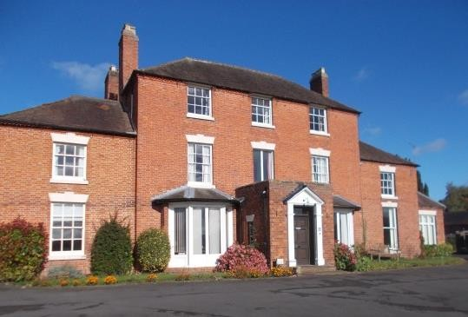
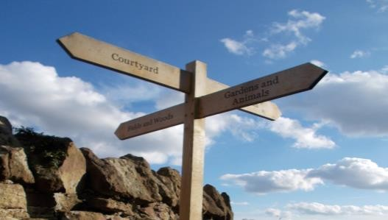
Parent and student information

for a residential visit

Where is Edgmond Hall?

How to find us

Directions
Follow Sat. Nav. using postcode below.
Situated in Edgmond village opposite
St Peters’ Church The adventure starts here!
Edgmond Hall
41 High Street A warm welcome awaits!
Edgmond, Newport TF10 8JY

Phone: 0121 569 4440 ·Getting Outdoors·Having Fun· edgmond_hall@sandwell.gov.uk ·Exploring·Working Together· sandwellresidentials.co.uk ·Meeting the Animals·
·Personal Development·
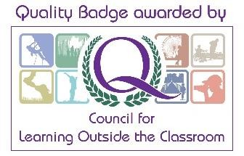
Learning New Skills·

·Positive Wellbeing·
·Creating Memories for Life·

…returning with experiences, skills and memories to share with you at home!

Welcome to Edgmond Hall
Edgmond Hall is one of four centres that make up Sandwell Residential Education Service. It was bought by Oldbury Council in 1936 and converted a year later. It has been a Centre for residential education for over 80 years!
Edgmond Hall is in Shropshire. It sits on the edge of the historic village of Edgmond. It was originally a Georgian Farm House and still reflects this in the Grade II listed main house and outbuildings. It is set in 45 acres of grounds; including woodland, meadow, orchard and old marshland habitats as well as having playing fields and more traditional gardens.

Accommodation
The main house accommodates up to 50 in comfortable dormitory style bedrooms split over two floors. The toilets and showers are located on each floor next to the bedrooms.
The staff bedrooms are on each floor located close to the dormitories to enable good supervision. There are staff bathroom facilities near to their bedrooms.
Edgmond cottage is situated next to the courtyard opposite the main house with 12 more beds. It is fully accessible for wheelchair users or those with additional needs.
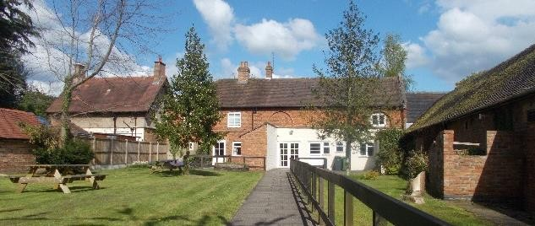

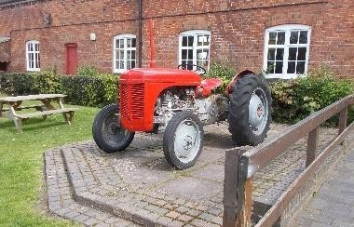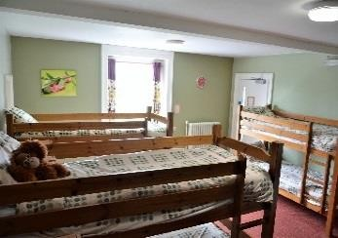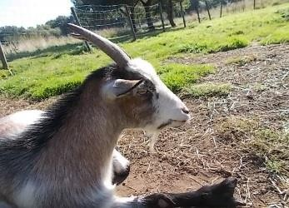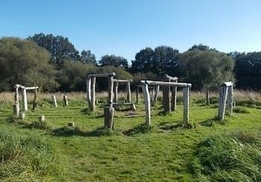

Facilities
- Large playing field with adventure play ground
- Boot room and locker room for keeping belongings to use outside
- Dining room, staff room, cloakroom and toilets in the main house
- Indoor classroom spaces, including the large classroom in the old barn
- Indoor games room
- Toilets and handwashing in the courtyard for easy access outdoors
- Gift Shop – containing souvenirs.
- The old Billiard room, with tv, quiet games, blackboards and drawing materials.
- 17 seater minibus for exploring the local area.

Meals
We aim to provide food that the children will enjoy and that is broadly balanced. We encourage healthy eating by having fresh fruit and vegetables as part of the meals each day. We have a fixed menu, whilst also catering for those with specific dietary requirements using robust procedures.
Each day there is breakfast, a packed lunch, a cooked evening meal and hot chocolate and a homemade biscuit for supper. Children are well fed and don’t need to bring their own snacks! Staff
We have an experienced and friendly team of tutors and support staff who are dedicated to:
- Providing a friendly, safe, homely environment
- Providing a high quality educational experience
- Working closely with visiting staff

Courses
We work closely with teaching staff to plan and design the programme to meet the specific needs of the group. This may focus on personal development; link directly with the curriculum; be a school topic; or might be a themed course. For each group coming to Edgmond Hall we will always strive to: Explore Outdoors; Have Fun; Recognise Every Child as Unique; Bring Learning to Life and Create Fantastic Memories.

…continue the adventure at Edgmond Hall

